Found Quasars around G124 (RA-192.2680833 dec-48.3460278)

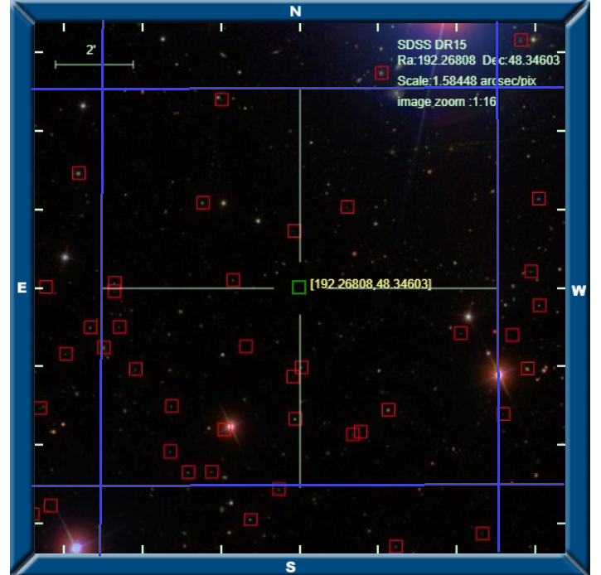

Image, blue radius around G124 is 5” from skysurver.sdss.org

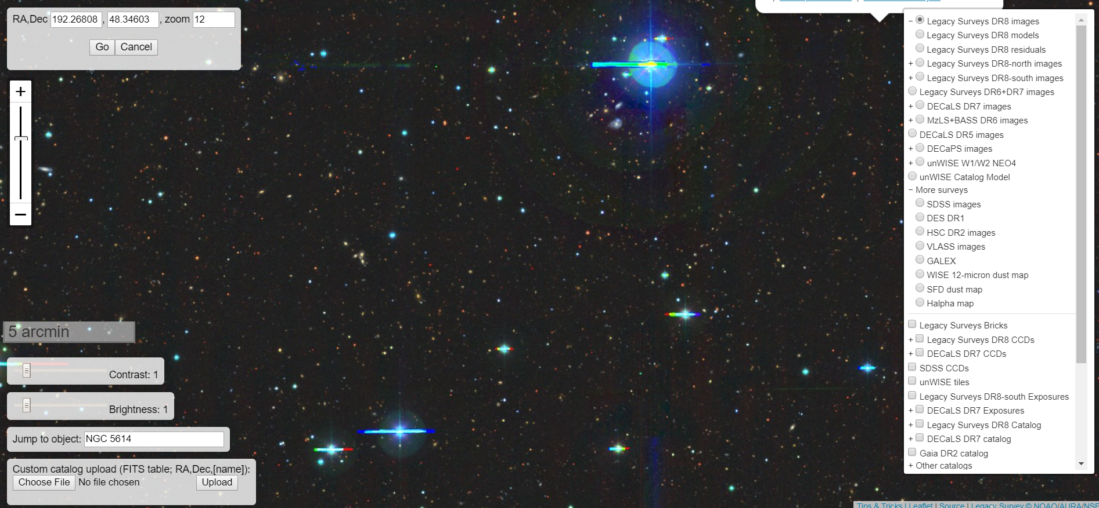

Image from legacy survey

|  |  |  |  |  |  |  |
| --- | --- | --- | --- | --- | --- | --- |
| **Quasar Name** | **Classification on SDSS** | **Redshift** | **RA** | **dec** | **Spectrum** | **Distance (arcmin)** |
| 1237661435921105230 | QSO Broadline | 1.451674 | 192.38713 | 48.34502 | [Spectrum 1](http://skyserver.sdss.org/dr15/en/get/SpecById.ashx?id=8348561122446516224) | <5 |
| 1237661358620278918 | QSO Broadline | 2.268088 | 192.26741 | 48.31274 | [Spectrum 2](http://skyserver.sdss.org/dr15/en/get/SpecById.ashx?id=7505479508465524736) | <2 |
| 1237661358620278833 | QSO | 1.003029 | 192.31675 | 48.28628 | [Spectrum 3](http://skyserver.sdss.org/dr15/en/get/SpecById.ashx?id=7505479783343431680) | <5 |
| 1237661358620279188 | QSO Broadline | 3.172016 | 192.35039 | 48.29621 | [Spectrum 4](http://skyserver.sdss.org/dr15/en/get/SpecById.ashx?id=7505478683831803904) | <5 |
| 1237661358620278939 | QSO Broadline | 1.402177 | 192.33966 | 48.26848 | [Spectrum 5](http://skyserver.sdss.org/dr15/en/get/SpecById.ashx?id=7505478958709710848) | <6 |
| 1237661358620213686 | QSO Broadline | 1.924046 | 192.13274 | 48.32641 | [Spectrum 6](http://skyserver.sdss.org/dr15/en/get/SpecById.ashx?id=8348573217074421760) | <6 |

|  |  |  |
| --- | --- | --- |
| [Info Page 1](http://skyserver.sdss.org/dr15/en/tools/explore/Summary.aspx?id=1237661358620279188) | [Info Page 2](http://skyserver.sdss.org/dr15/en/tools/explore/Summary.aspx?id=1237661358620278918) | [Info Page 3](http://skyserver.sdss.org/dr15/en/tools/explore/Summary.aspx?id=1237661358620213686) |

Program Spectrum results for the promising QSO candidates

QSO 1

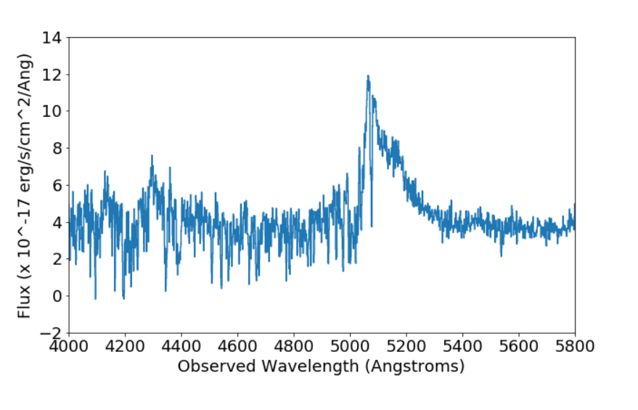

QSO 2

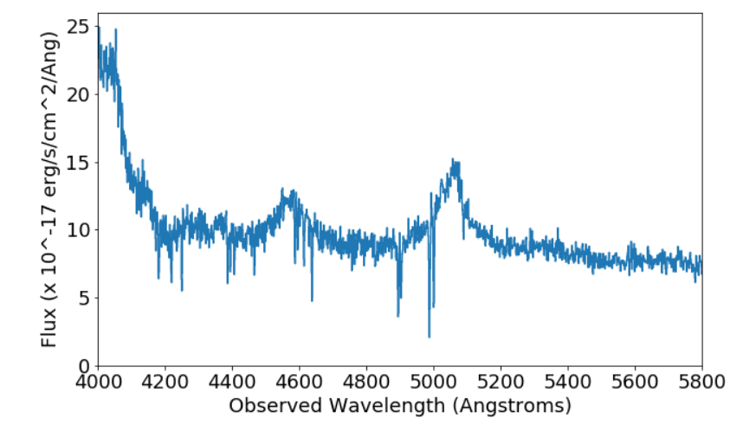

QSO 3

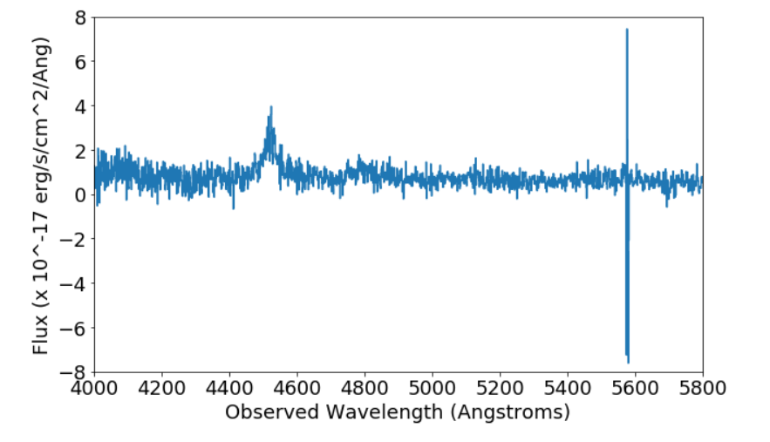

|  |  |  |  |  |  |  |
| --- | --- | --- | --- | --- | --- | --- |
| **Star Name** | **Classification on SDSS** | **Redshift** | **RA** | **dec** | **Spectrum** | **Distance (arcmin)** |
| 1237661435921105134 | Star AO | 6.280673E-06 | 192.38684 | 48.34853 | [Spectrum 7](http://skyserver.sdss.org/dr15/en/get/SpecById.ashx?id=3790997704046387200) | <5 |
| 1237661435921105185 | Star M4.5:III | 0.0001133032 | 192.31108 | 48.34980 | [Spectrum 8](http://skyserver.sdss.org/dr15/en/get/SpecById.ashx?id=8348574866341863424) | <2 |
| 1237661435921104950 | Star FOIV | -0.0003061841 | 192.31858 | 48.42651 | [Spectrum 9](http://skyserver.sdss.org/dr15/en/get/SpecById.ashx?id=7505477584320176128) | <2 |
| 1237661358620213368 | Star M1 | 8.50132E-05 | 192.21188 | 48.29473 | [Spectrum 10](http://skyserver.sdss.org/dr15/en/get/SpecById.ashx?id=8349850569892929536) | <4 |
| 1237661358620279482 | Star M6III | 0.000100126 | 192.22987 | 48.28550 | [Spectrum 11](http://skyserver.sdss.org/dr15/en/get/SpecById.ashx?id=8348572392440700928) | <4 |
| 1237661358620278920 | Star K3V | -0.0001123213 | 192.27145 | 48.29082 | [Spectrum 12](http://skyserver.sdss.org/dr15/en/get/SpecById.ashx?id=8348573766830235648) | <4 |
| 1237661358620279121 | Star M5III | -0.0001136673 | 192.28186 | 48.26131 | [Spectrum 13](http://skyserver.sdss.org/dr15/en/get/SpecById.ashx?id=8348571842684887040) | <6 |
| 1237661358620279155 | Star G8V | -0.0003565836 | 192.32477 | 48.26870 | [Spectrum 14](http://skyserver.sdss.org/dr15/en/get/SpecById.ashx?id=8348574316586049536) | <6 |
| 1237661358620279190 | Star K3V | 1.67455E-07 | 192.35123 | 48.27718 | [Spectrum 15](http://skyserver.sdss.org/dr15/en/get/SpecById.ashx?id=8348559473179074560) | <7 |
| 1237661358620278922 | Star G4V | -0.0001643798 | 192.29992 | 48.24831 | [Spectrum 16](http://skyserver.sdss.org/dr15/en/get/SpecById.ashx?id=8348571292929073152) | <6 |

|  |  |  |  |  |  |  |
| --- | --- | --- | --- | --- | --- | --- |
| **Galaxy Name** | **Classification on SDSS** | **Redshift** | **RA** | **dec** | **Spectrum** | **Distance (arcmin)** |
| 1237661435921105155 | Galaxy | 0.3500836 | 192.33059 | 48.38265 | [Spectrum 17](http://skyserver.sdss.org/dr15/en/get/SpecById.ashx?id=1638350442536658944) | <4 |
| 1237661435921105408 | Galaxy | 0.7846245 | 192.27214 | 48.37077 | [Spectrum 18](http://skyserver.sdss.org/dr15/en/get/SpecById.ashx?id=8349859915741765632) | <2 |
| 1237661435921105313 | Galaxy | 0.6053908 | 192.23805 | 48.38088 | [Spectrum 19](http://skyserver.sdss.org/dr15/en/get/SpecById.ashx?id=7505465214814363648) | <3 |
| 1237661358620213731 | Galaxy Starforming | 0.2027058 | 192.16578 | 48.32718 | [Spectrum 20](http://skyserver.sdss.org/dr15/en/get/SpecById.ashx?id=8348572942196514816) | <5 |
| 1237661358620279302 | Galaxy | 0.6066732 | 192.23474 | 48.28419 | [Spectrum 21](http://skyserver.sdss.org/dr15/en/get/SpecById.ashx?id=7505467963593433088) | <4 |
| 1237661358620279333 | Galaxy | 0.5371011 | 192.27273 | 48.30879 | [Spectrum 22](http://skyserver.sdss.org/dr15/en/get/SpecById.ashx?id=8348574041708142592) | <4 |
| 1237661358620279202 | Galaxy | 0.4884596 | 192.37336 | 48.31195 | [Spectrum 23](http://skyserver.sdss.org/dr15/en/get/SpecById.ashx?id=7505478408953896960) | <5 |
| 1237661435921105165 | Galaxy | 0.3068829 | 192.39366 | 48.32111 | [Spectrum 24](http://skyserver.sdss.org/dr15/en/get/SpecById.ashx?id=1638354290827356160) | <6 |
| 1237661435921105617 | Galaxy | 0.7769666 | 192.38376 | 48.32980 | [Spectrum 25](http://skyserver.sdss.org/dr15/en/get/SpecById.ashx?id=8349860465497579520) | <5 |